Task 6: Components

Concept of Components in CSS
CSS components refer to reusable blocks of styles that represent a specific UI element or feature (e.g., buttons, cards, navbars, etc.). By encapsulating a piece of UI into a component, you can reuse it across different parts of your project, which leads to more organized, maintainable, and scalable code. Components follow the DRY principle (Don't Repeat Yourself), which minimizes code duplication and makes it easier to update or modify.
Components are often styled with clear class names and can be enhanced using a CSS preprocessor like Sass to add dynamic functionality, nesting, variables, and modularity.

Creating a Sample Card Component Using Sass
Let’s create a card component using Sass that includes an image, title, description, and a button. We will structure it using variables, nesting, and component-specific styles.
// Variables for reuse
$primary-color: #3498db;
$secondary-color: #2ecc71;
$border-radius: 8px;
$card-padding: 20px;

// Card component styles
.card {
border: 1px solid #ddd;
border-radius: $border-radius;
overflow: hidden;
box-shadow: 0 4px 8px rgba(0, 0, 0, 0.1);
padding: $card-padding;
background-color: white;

// Nested elements inside card
&__image {
width: 100%;
height: auto;
display: block;
}

&__title {
font-size: 1.5rem;
color: $primary-color;
margin-bottom: 10px;
}

&__description {
font-size: 1rem;
color: #333;
margin-bottom: 15px;
}

&__button {
display: inline-block;
padding: 10px 20px;
background-color: $secondary-color;
color: white;
text-decoration: none;
border-radius: $border-radius;
transition: background-color 0.3s;

&:hover {
background-color: darken($secondary-color, 10%);
}
}
}

Explanation:
- Variables: We define variables such as $primary-color, $secondary-color, $border-radius, and $card-padding to easily manage and reuse values throughout the component.
- Nesting: The &__ notation (BEM methodology) is used to nest styles for different parts of the card (.card__image, .card__title, .card__description, .card__button), ensuring the structure is clean and modular.
- Button Hover State: The &:hover pseudo-class is used for the button, changing its background color on hover.
Compiled CSS Output:
- /* Compiled CSS */
- .card {
- border: 1px solid #ddd;
- border-radius: 8px;
- overflow: hidden;
- box-shadow: 0 4px 8px rgba(0, 0, 0, 0.1);
- padding: 20px;
- background-color: white;
- }

- .card__image {
- width: 100%;
- height: auto;
- display: block;
- }

- .card__title {
- font-size: 1.5rem;
- color: #3498db;
- margin-bottom: 10px;
- }

- .card__description {
- font-size: 1rem;
- color: #333;
- margin-bottom: 15px;
- }

- .card__button {
- display: inline-block;
- padding: 10px 20px;
- background-color: #2ecc71;
- color: white;
- text-decoration: none;
- border-radius: 8px;
- transition: background-color 0.3s;
- }

- .card__button:hover {
- background-color: #27ae60;
- }

Example HTML Using the Card Component:
<div class="card">
<img src="image.jpg" alt="Card image" class="card__image">
<h2 class="card__title">Card Title</h2>
<p class="card__description">This is a description of the card. It explains the content in brief.</p>
<a href="#" class="card__button">Read More</a>
</div>

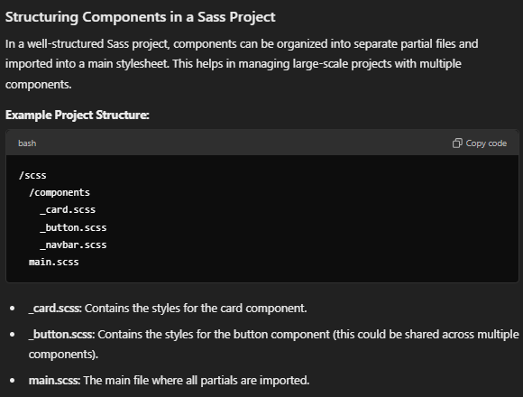
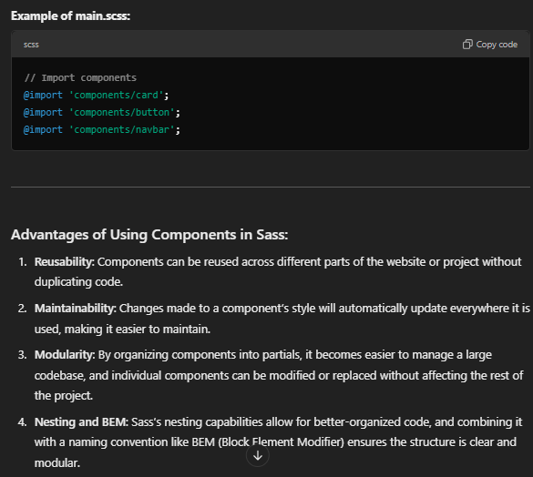

Conclusion:
CSS components in Sass greatly improve code reusability, scalability, and maintainability. By breaking the UI into smaller, reusable parts, Sass helps streamline development, especially in larger projects where consistency and flexibility are essential.

